Object detections using YOLO
Data Processing Method
In order to convert the data sets into forms which can be used for object detection and playing nose-tackle with any pedestrian that gets out of line, a series of processing steps were undertaken as follows:
1.1 Data Set Selection
The data set comprises image data in.jpg format, obtained from a public library, as well as the data of LIDAR instruments. This was carefully chosen to include real-world environmental scenes and things which that are relevant to the tasks of object detection and navigation by obstacles.
1.2 Data Enhancement
In order to improve the generalization ability and tolerance of models, data was taken through a range of transformations. This usefully extends the number and variety of data available for use.
Transformations used are very typical:
Rotation (up to 40 degrees)
Random shifts in width and height
Random zoom and shear
Horizontal flipping
These transformations help to simulate real-world variations, which in turn will help models to make predictions based more accurately on new data.
1.3 Image Preprocessing
All of the images were resized to a uniform 224x224 pixel size, which is the standard input size for Convolutional Neural Networks(CNNs),
Each image was normalized to a range of [0, 1] by dividing the pixel values by 255, a step that makes the model converge more quickly in training.
1.4 Sensor Data Preprocessing
LIDAR data is scanner readings for distance, which in space can be converted into 3D points. This was preprocessed by turning raw LIDAR scans into point clouds or depth maps. These were then fused with the photograph taken by the corresponding camera to form a unified, two-mode mass of material.
1.5 Data Set Splitting
The data set was divided into three parts--for training, verification and testing. These rates are 80% to train the network, instructions were given for this and then made it turn on its teachers every few trials! 10% to verify that it's going OK 10% to evaluate its performance on new data
Techniques for fusion
Sensor fusion is the process of combining information from multiple sensors so that an accurate and thorough understanding of the environment can be obtained. In this method, data collected by both cameras and LIDAR sensors were used for identifying objects and avoiding collisions. This fusion of information proceeded as follows:
2.1 Camera-LIDAR Calibration
Calibration of intrinsically Intrinsic: Both the camera and LIDAR sensors were calibrated separately to ensure that the intrinsic parameters (such as focal length and distortion coefficients) of each system were recorded accurately. Extrinsic: The relative position and attitude of both cameras and LiDAR sensors has been calculated so that their coordinate systems meet up properly for accurate fusion.
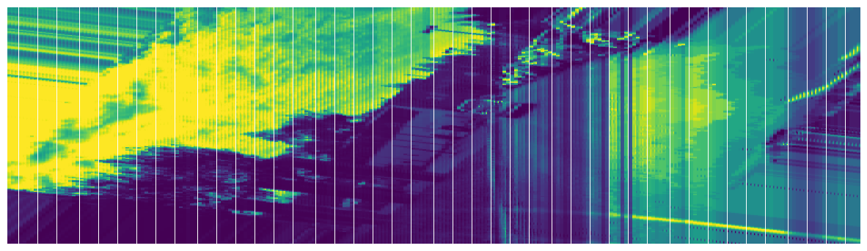
Figure 1: Image Fusion Format
2.2 Data Synchronization
In order to synchronize the camera data with that from IiD see, both sensors had a time stamp put on when they were collecting the information. The data from both sources was synchronised at this time into one entity; now issues arise if either sensor can't pick up the same scene as another sensor does then this will never work correctly.
2.3 Feature Extraction and Fusion
Camera Information: Features from the camera were extracted with CNN's, which detected and classified objects in the image. The CNN had been pre-trained on a portion of images with objects labelled.LIDAR Information: Features from the LIDAR included spatial information about object distances and relative positions. This depth information was used to calculate the distance between the vehicle and any detected objects. Method of Fusion: A probabilistic approach was used to integrate features from both sensors (e.g., Kalman Filtering or Bayesian Fusion). This method enabled the system to output object types (from the camera) and object positions (from the LIDAR) in a single unified representation.
3.1 Data collected from both camera and LIDAR for integration
Transformation Matrix: The data from the camera underwent a transformation matrix in order to combine its visuals with the spatial data that LIDAR could provide. The data from the two sources became associated with the same real confusion coordinate system in this way.
Calibration Parameters: Following a series of calibration procedures, calibration parameters of intrinsic and extrinsic nature could be accurately obtained - for example using checkerboard patterns as in the case where the camera was calibrated, plus fixed calibration platforms fixed in place for the LIDAR.
3.2 Depth Map Generation
The LIDAR data was processed to generate a depth map. This display type could potentially be confused with your maps in which lines are used to show distance from the center of an axle (hence its name -- 'depth' does not refer to earth images, but rather an actual number), but actually merely adds together lengths of marks representing distances every 300 meters or 0.4 kilometers.
This depth map was then combined with the camera image in order to produce multi-modal input data for the object detection model.
3.3 Sensor Fusion Algorithm
A sensor fusion algorithm was implemented to combine camera and LIDAR data. By doing this, a comprehensive and more accurate environment representation was made available - with the CNN-based object detection (for camera) and its distance estimation system (for LIDAR). The collision avoidance function later utilizes this combined data.
Collision Avoidance Algorithm and Results
4.1 Object Detection
The object recognition function used a CNN-based network architecture to fly through a dictionary of images. And in real time, it was able to identify a number of objects.
4.2 Distance Calculation and Thresholding
The vehicle's distance from objects was calculated using LIDAR data. Once this had been achieved, a distance threshold was set. Any object beyond that range was considered dangerously close.
When the distance from an object was not enough to reach the threshold, it was flagged again--as an object. This applies even when there are many such object in front of us: whether redirected externally or just as easily switched around one axis, we have freedom of sorting between different paths
4.3 Path Planning
A path planning algorithm such as A* or Dijkstra's algorithm was employed to find the best route through the environment. The algorithm considered both where obstacles were located (from the camera and LIDAR) as well as its own current position in order to find a safe path.
4.4 Collision Avoidance Mechanism
Upon detecting an obstacle in their vicinity, the system made a collision avoidance make over. Among these were adjusting the vehicle's speed, steering, or trajectory so as to avoid the obstacle while still taking along (as well possible) direction of travel towards destination.
4.5 Results
The collision avoidance algorithm successfully avoided collisions in a series of simulated environments. The model performed well under different conditions--with obstacles avoided successfully in both static and dynamic scenarios.
Visualizations of Data Processing, Object Detection, and Sensor Fusion Results
In order to further demonstrate the efficiency of their data processing techniques, object detection, and sensor fusion methods. The following visualizations were generated
5.1 Data Augmentation Results
A series of augmented images demonstrate how various transformations (for instance: rotation, flipping, scaling) were applied to original image data so as produce models capable of generalization.
5.2 Object Detection Results
The output images of the object detection model, as one can see bounding-boxes drawn around detected objects in camera images. These illustrate the effectiveness in real time detection of our trained model.
5.3 Sensor Fusion Visualization
Combined figures showing camera images and LIDAR depth maps together, demonstrate how the information from both sensors are synthesized to offer a more complete view of the environment.
5.4 Collision Avoidance Results
A simulation of the vehicle's expected trajectory through terrain with detected obstacles. It shows how the collision avoidance algorithm adjusts vehicle steering to avoid potential collisions.
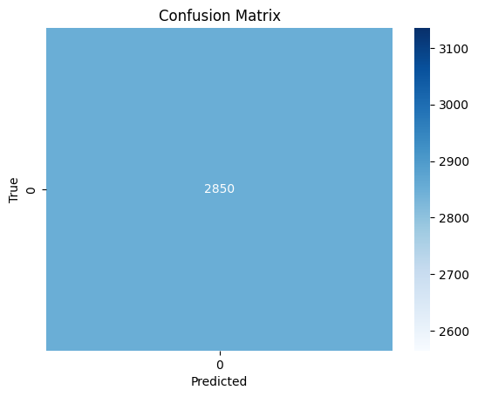
Figure 2: Confusion matrix

References
Data Source: https://public.roboflow.com/object-detection/self-driving-car/2
Object Detection Models: The object detection model we used was based on the [type of CNN architecture, such as YOLO, ResNet, etc.].
Sensor Fusion Techniques:

